**NarcoTech**

**Marketing Plan**

**Alexa Physio Reminder Skill**

**Appointment Reminder System for O.P.S**

**Team Members Contact**

Tarika Birch (PRO) tarika.birch@mycavehill.uwi.edu

Dwayne Archer dwayne.archer@mycavehill.uwi.edu

Kai Hill kai.hill@mycavehill.uwi.edu

Aaron Grimes aaron.grimes@mycavehill.uwi.edu

Kelilah Mayers kelilah.mayers@mycavehill.uwi.edu

Contents

Executive Summary 3

Business Overview 3

Market Research 4

Marketing Strategy 6

Budget 7

Marketing Goals and Objectives 8

Implementation Timeline 9

Monitoring and Measurement 9

Example of Creative 10

Contingency Plan 10

Conclusion 10

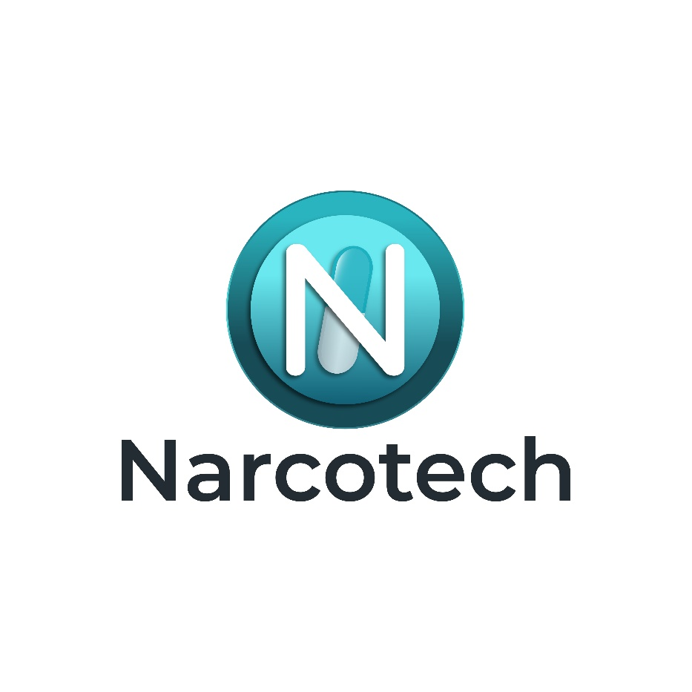

# Executive Summary

NarcoTech’s marketing plan aims to introduce an Alexa skill which caters to the specific needs of individuals aged 65 and older in Barbados suffering from Repetitive Strain Injury (RSI) in the Achilles Tendon. The skill focuses on appointment reminders for physical therapy sessions, addressing a crucial need in the market. The key goal is to successfully launch the product and capture market share through radio, newspaper, Facebook, and Instagram advertisements. In addition to this, Flyer promotions will occur within the O.P.S (Optimal Physiotherapy Services) building. NarcoTech’s strength lies in its targeted approach and understanding of the target market, promising a reliable solution for managing physiotherapy appointments.

# Business Overview

NarcoTech, being a software company in the medical field, is especially dedicated to enhancing the lives of individuals through innovative and technological means. Our mission is to provide reliable software to all our clients in a quantifiable, systematic, and disciplined manner. Our product, Physio Reminder, assists patients in managing their physical therapy sessions effectively. Currently, the market lacks a specialized solution for this demographic which positions NarcoTech uniquely in the industry.

# Market Research

**Market Analysis**

Reminders on Amazon Alexa is certainly an industry that has already been tapped into, however the market is unsaturated. The main competitor in this industry is Amazon’s built-in reminder system, Alexa reminders. The Alexa Skill is a general one and thus caters to a broad range of use cases. NarcoTech’s reminder skill is a specialized skill that caters to appointment reminders for physical therapy. While it is estimated that a percentage of the target audience may be satisfied with the Amazon Alexa built-in features, most would prefer a specialized skill catered to their specific needs.

**Target Audience**

The target audience are persons 65 years or older, specifically within the island of Barbados that either suffer from Repetitive Strain Injury (RSI) in the Achilles Tendon currently or are at risk of suffering from it in the future. This market size is approximately 30,930 people. These individuals tend to have difficulty managing their physiotherapy sessions. This stems from the challenge of remembering their appointments with their physical therapists. They need an application which can assist them with this issue. A customer avatar Canvas has been provided below:

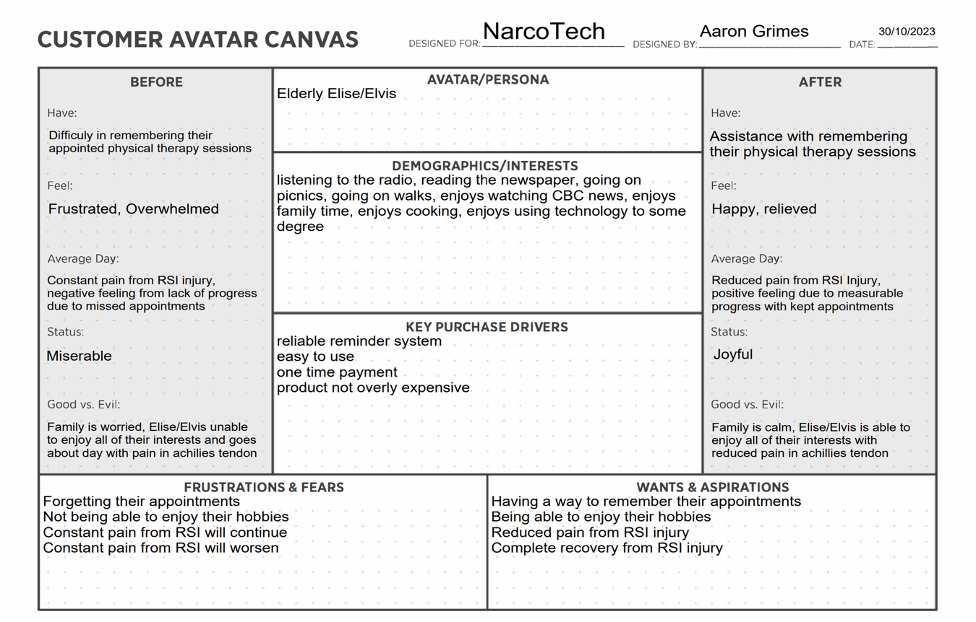

**SWOT Analysis**

The NarcoTech team’s strengths, weaknesses, opportunities and threats have been outlined below. The strengths outweigh the weaknesses, and the opportunities outweigh the threats. Despite this being the team’s first project of this nature, the skill is not difficult to implement, and the team is more than capable of handling the task. Moreover, people that are resistant to modern technologies are more willing to adapt to the tech’s capabilities if it solves a specific problem that they face.

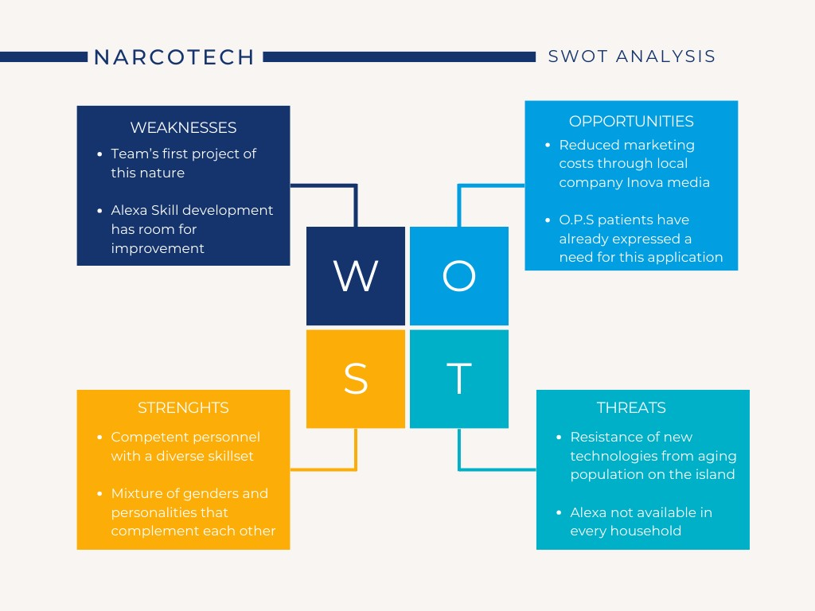

|  |  |  |  |
| --- | --- | --- | --- |
| Strengths | Weaknesses | Opportunity | Threats |
| * Voice commands are a natural way to interact with technology. Hence, this will reduce the learning curve needed to operate NarcoTech’s Alexa Skill. * Helps with memory retention of physiotherapist appointments which gives patients a peace of mind. | * One weakness of NarcoTech’s Alexa skill is that the user must open the reminder skill to see their appointments. Therefore, no sound notification will occur. | * The skill has the potential to be monetized through Alexa app. As a result, the funds can offset some of the costs associated with building the skill. * The skill is versatile and can be used to aid patients with other types of injuries. | * One potential threat is that Amazon frequently make changes to AWS which may affect the performance and maintenance of the skill in the future. |

# Marketing Strategy

**Positioning**

The unique selling position (USP) for this project is its specialization in reminders for physical therapy sessions of persons aged 65 years of age or older. With the opportunity presented by O.P.S patients showing a want for a skill of this nature, NarcoTech can position the Alexa Skill directly in the hands of those that have already shown intention to use it. Moreover, O.P.S can be used as a marketing channel for potential customers

**Product**

An Alexa skill known as Physio Reminder will remind patients of their upcoming physical therapy sessions. Benefits of this product include a reliable reminder system for appointments and a more optimized rehabilitative process for the patient.

**Price**

Value-based pricing has been selected as the best pricing strategy for this project given the USP of the skill. Patients of O.P.S will have a perceived value of the Alexa Skill and are therefore willing to spend money to obtain its benefits. Upon assessing the market, a one-time fee of $5 BDS is the best possible pricing option.

**Place**

The product will be distributed online through Amazon Alexa Skills Shop.

**Promotion**

Given that the target audience consists of persons aged 65 and older, the product will be promoted through Radio ads, Newspaper ads and Facebook ads. The creatives generated for these avenues will also be placed inside of the O.P.S building. The allocation of NarcoTech’s financial resources towards these marketing avenues is highlighted in the budget section below.

# Budget

Radio ads, Newspaper ads and Facebook ads are the avenues that have been selected to market this project. The weight of their allocation, with a $3000 budget, is displayed below:



**Justification for Radio Ads | Cost: $1057.44**

The target market spends a substantial amount of their time listening to the radio. The news station that has been selected is CITA Radio due to their competitive pricing being the cheapest on the island. NarcoTech has selected the Premium time 12 ads in a month package for $1057.44

**Justification for Newspaper Ads | Cost: $1768**

The disadvantage of Radio ads is that there are multiple stations to choose from. This therefore means that a percentage of the target audience may not listen to CITA radio at all. With the newspaper, there is only Nation News. Therefore, this is an avenue that will bring a large ROI. This is why the budget is heavily skewed towards this avenue. A ¼ page ad in color for $1768 has been selected.

**Justification for Facebook Ads | Cost: $150**

A fraction of the target audience uses Facebook occasionally. To reach them, specialized ads will be done through Meta Business Suite. Inova Media has agreed to handle the ads and generate physical and digital creatives for $150. The Physical creatives will be placed inside of the O.P.S building.

# Marketing Goals and Objectives

* To have a successful product launch
* To gain 30% of market share from radio ads after a 1-and-a-half-month period
* To gain 45% of market share from Nation news ad after a 1-month period
* To gain 10% of market share from Facebook ads after a 1-month period
* To gain 15% of market share from Flyer creatives after a 2-month period

# Implementation Timeline

|  |  |  |  |
| --- | --- | --- | --- |
| Objective | Start date | End Date | Description |
| Product Launch | Monday, 20th November |  | Upon approval from O.P.S, the project will be launched to the Public |
| Radio Ads | Tuesday, 21st November | Thursday, 21st December | Radio Ads will run for a 1-month period, however full market share is expected to be gained for another 15 days (about 2 weeks) after ads have stopped running |
| Newspaper Ads | Sunday, 26th November | Sunday, 26th November | Ad will be released in the Sunday Sun. Usually an Ad from the nation news takes a month to see the full ROI |
| Facebook Ads | Tuesday, 21st November | Thursday, 21st November | Progress from Facebook ads will be monitored throughout the month. Ad set will be killed at end of month. ROI is seen immediately |
| Flyer Creatives | Monday 27th November |  | Flyers which promote the product will be placed in O.P.S Building |

# Monitoring and Measurement

They key performance Indicators (KPIs) for the ads are:

* Number of skill downloads
* Number of calls
* Number of increased appointments kept
* Number of clicks on Facebook ad

Throughout the advertising stages, these KPIs will be monitored carefully. Crucial decisions such as refining the Facebook ad targeting approach or constructing a different radio ad set will be swiftly implemented if the KPIs indicate suboptimal performance for the marketing strategy.

# Example of Creative

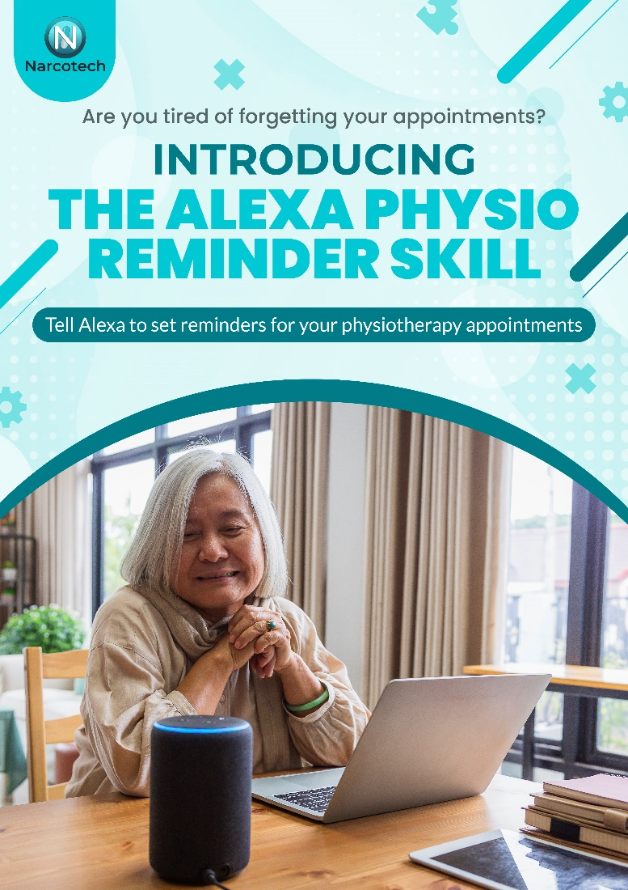

# Contingency Plan

In the event that the advertising channels fail to yield satisfactory results, NarcoTech will generate commercials tailored for CBC news. In addition to this, a renewed focus will be placed on genuine word-of-mouth from O.P.S staff to the desired target market. This approach would be a slower approach; however, it harnesses the credibility and trust that current patients have with O.P.S and their physical therapists and therefore would yield results overtime.

# Conclusion

NarcoTech’s specialized Alexa skill addresses a critical need in the market, offering appointment reminders for individuals struggling with RSI in the Achillies Tendon within Barbados. Through a well-planned marketing strategy, the company aims to establish a strong market presence and provide significant value to O.P.S patients. With a strategy based on the USP which utilized performance metrics, NarcoTech is positioned for success at the product launch and initial advertising stages of the product.